

**WEB TECHNOLOGY**

**LAB WORK**

**NAME:KATHIRAVAN.N**

**REG.NO:19MIS0097**

**1.** **Design the following nested list using HTML code.**

**HTML CODE:**

<html>

<head>college cources</head>

<h1>List of available cources</h1>

<ul>

<li>Datastructure & algorithm</li>

<li>Web technology</li>

<li>Apptitude & Logical Reasoning</li>

<li>Programming Language</li>

</ul>

</html>

**INPUT:**

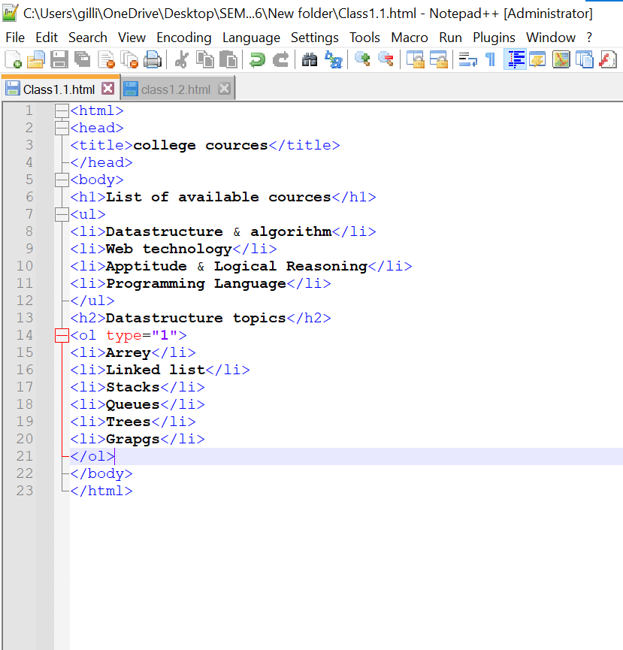

**OUTPUT:**

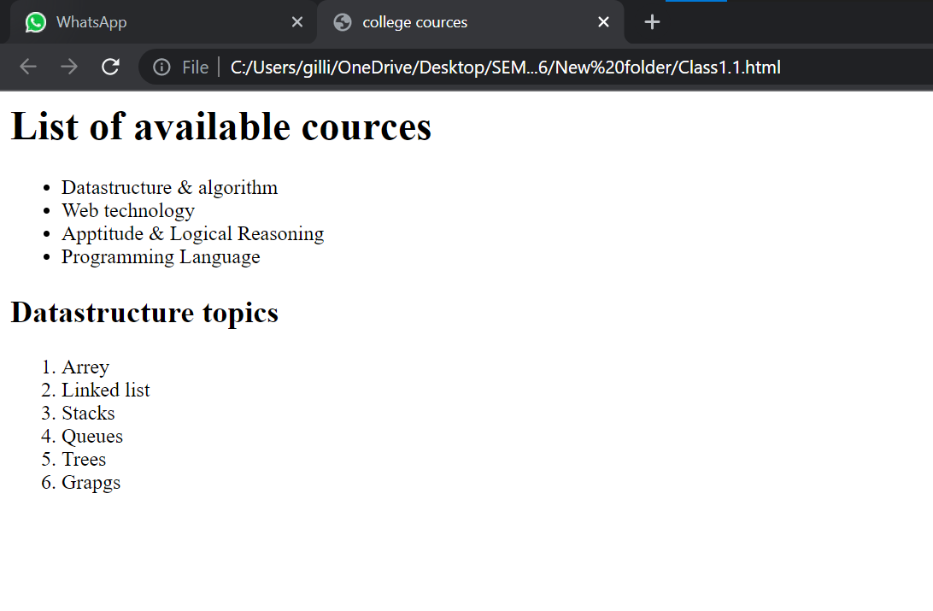

**2.** **Design the following nested list using HTML code.**

**HTML CODE:**

<html>

<head>

<title>States and districts</title>

</head>

<body>

<h1>States</h1>

<ol type="1">

<li>Andhra pradesh</li>

<li>Karnataka</li>

<ol type="i">

<li>District1</li>

<li>District2</li>

<li>District3</li>

</ol>

<li>telangana</li>

<ul>

<li>Country1</li>

<li>country2</li>

</ul>

<li>Utter pradesh</li>

</ol>

</body>

</html>

**INPUT:**

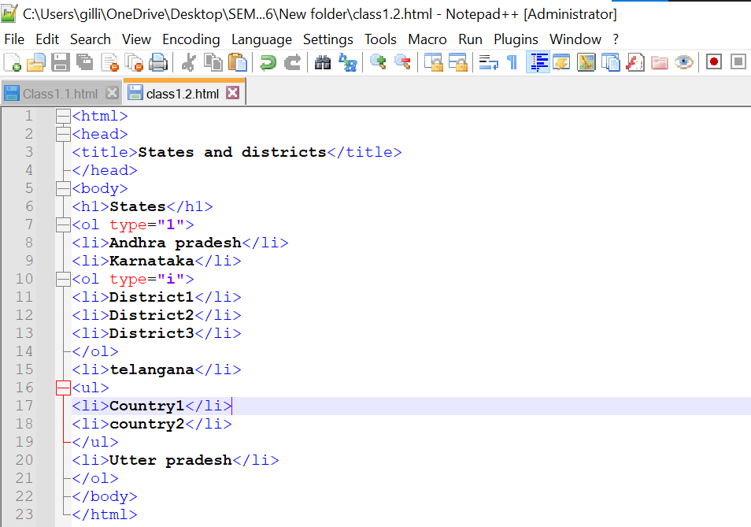

**OUTPUT:**

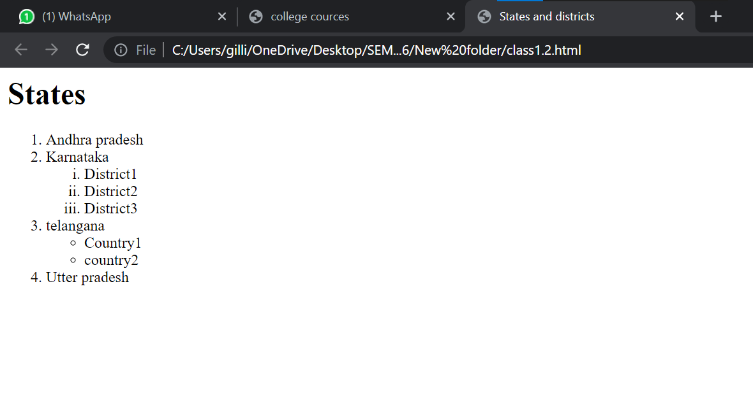

**3.** **Design the following nested list using HTML code:**

**HTML CODE:**

<html>

<head>

<title>Game</title>

</head>

<body>

<br>Break.</br>

<ul>

<li>Root level</li>

<ul type="circle">

<li>Second level</li>

<ul type="square">

<li>Third level</li>

</ul>

<li>Back to second level</li>

</ul>

</ul>

<br>Break again.</br>

<ol type="1">

<li>Root level</li>

<ul type="circle">

<li>Second level</li>

<li>Third level</li>

<li>Back to second level</li>

</ul>

</ol>

<br>Final break.</br>

<ol>

<li>Root level</li>

<ul type="circle">

<li>Second level</li>

<ul type="square">

<li>Third level</li>

</ul>

<li>Back to second level</li>

</ul>

</ol>

<br>End of exmple</br>

</body>

</html>

**INPUT:**

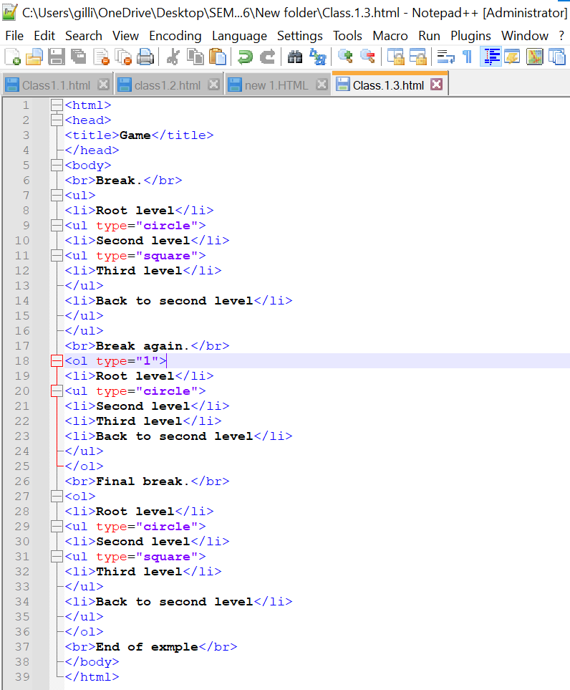

**OUTPUT:**

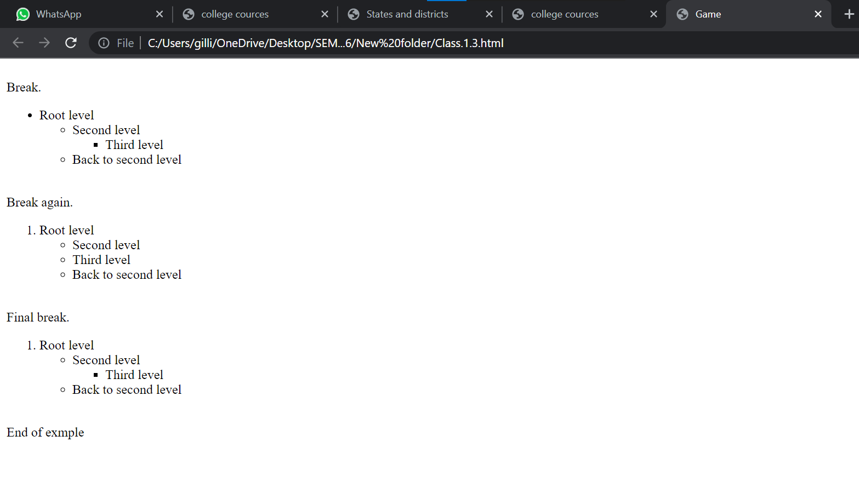

**4.** **Design the following nested list using HTML code:**

**HTML CODE:**

<html>

<head>

<title>Grammer</title>

</head>

<body>

<br>verbs:</br>

<ol type="1">

<li> Conjugation</li>

<ol type="a">

<li>Present Tense</li>

<ol type="i">

<li>3 Letter Verbs</li>

<ol type="1">

<li>Regular</li>

<ol type="a">

<li>Middle letter is a consonant</li>

<li>See Chart in notebook for conjugation</li>

<li>"I form" determines conjugation and is different from<br>infinitive form</br></li>

<li>You(m)-They switches harakes of the first two letters.</li>

<li>Exception</li>

<ol type="i">

<li>2ija(to come)has alif masourah</li>

<ol type="1">

<li>Skin alif when conjugation</li>

<li>Alif masourah turns into a ya when<br>conjugating</br></li>

<li>You(p)and they switches "ya"with "wow"</li>

</ol>

</ol>

</ol>

<li>Irregular</li>

<ol type="a">

<li>Middle letters is alif or consonant with shadded+fatha</li>

<ol type="i">

<li>Alif-switches to wow or ya</li>

<li>Shaddeh-fatha stitches to kasra

</ol>

<li>See Chart in notebook for conjugations</li>

<li>Exceptions</li>

</ol>

</ol>

<li>4 Letter Verbs</li>

<li>5 Letter Verbs</li>

<li>2 Letter Verbs</li>

</ol>

<li>Past Tense</li>

<li>Present continuous</li>

<li>Past continuous</li>

<li>Future Tense</li>

<li>Far Past</li>

</ol>

</ol>

<br>Imperative</br>

</body>

</html>

</html>

**INPUT:**

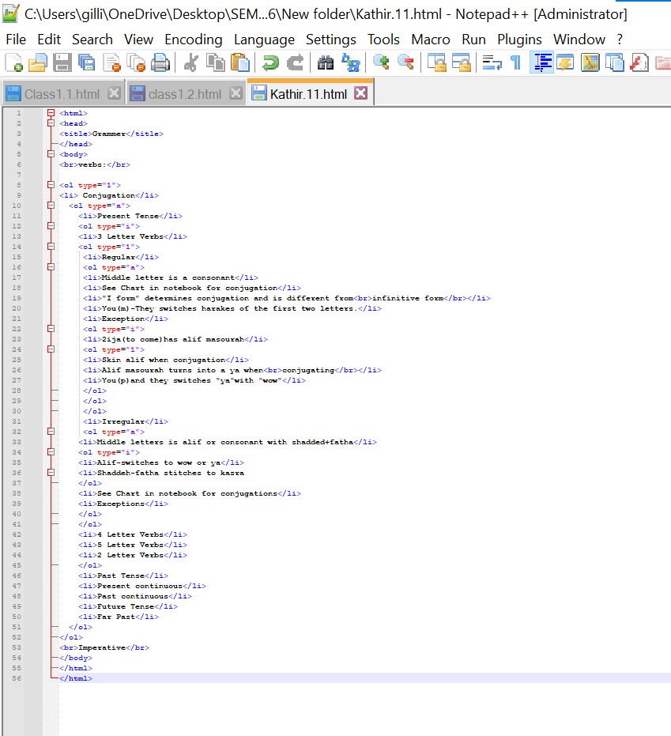

**OUTPUT:**

